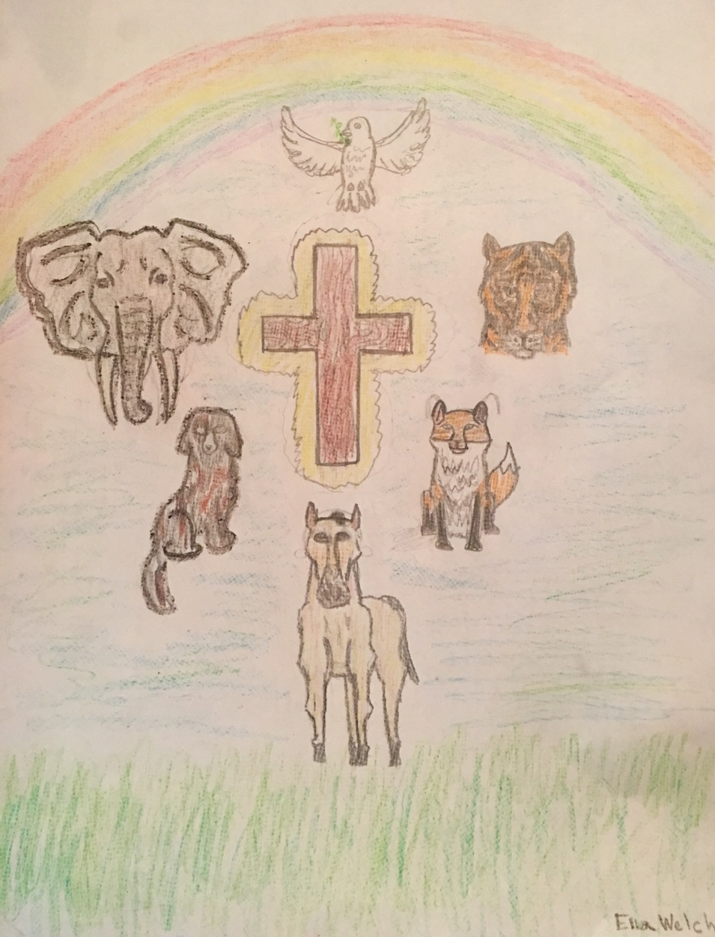

October 2, 2022
Blessing of the Animals

+ The Seventeenth Sunday After Pentecost +
October 2, 2022 Blessing of the Animals 10:00 a.m.

The responses of the assembly appear in bold type.
We are invited today to gather in consideration of our place within all creation.
The Gospel reminds us of our rightful place as servants and stewards of this creation. The “Blessing of the Animals” we celebrate this day reminds us of our vocation and caretakers of creation and the responsibility we hold with those with whom we share this planet.”
“ELW” refers to Evangelical Lutheran Worship, the cranberry-colored book in the pew racks.

Gathering
The Holy Spirit calls us together as the people of God

Announcements

Prelude This Is My Father’s World
Terra Patris
Melody by Franklin L. Sheppard (1852-1930)
Words by Maltbie D. Babcock (1858-1901)

Malinda Walter, flute

This is my Father’s world, and to my list’ning ears,
All nature sings, and round me rings
The music of the spheres.
This is my Father’s world: I rest me in the thought
Of rocks and trees, of skies and seas;
His hand the wonders wrought. [ELW# 824]

Greeting and Invocation Litany

P: The animals of God's creation inhabit the skies, the earth, and the sea.
They share in the fortunes of human existence
and have a part in human life.
God, who confers gifts on all living things,
has often used the service of animals
or made them reminders of the gifts of salvation.
Animals were saved from the flood and afterwards made a part of the covenant with Noah.
The paschal lamb recalls the passover sacrifice and the deliverance from slavery in Egypt. (E
A giant fish saved Jonah;
ravens brought bread to Elijah;
animals were included in the repentance of Nineveh;
and animals share in Christ's redemption of all God's creation.
We, therefore, invoke God's blessing on these animals this day.
As we do so, let us praise the Creator, Redeemer and Sanctifier this day,
Thanking God for setting us as stewards
over all the creatures of the earth.
Hymn of Praise All Glory Be to God
Foundation
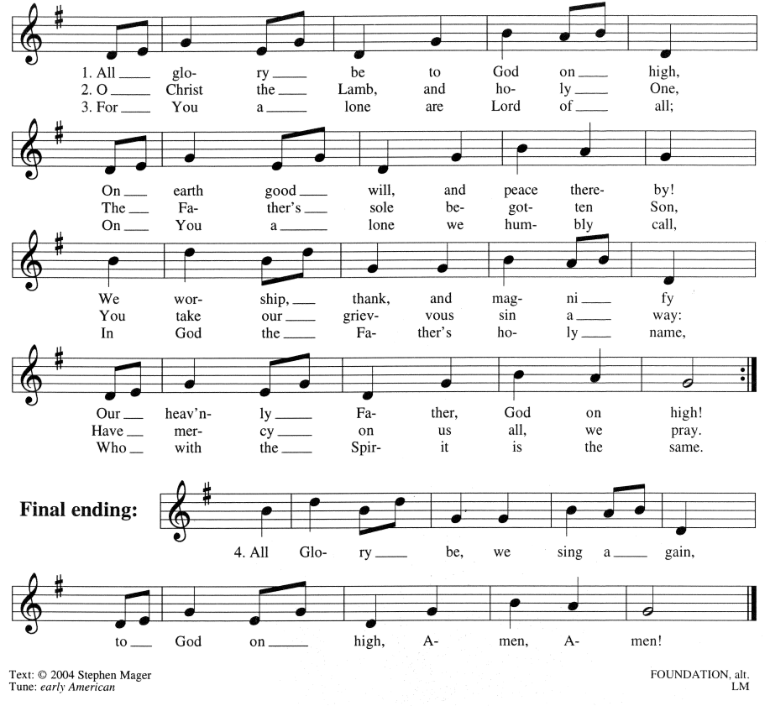

Prayer of the Day

Let us pray.
Source and sustainer of life, we cherish the myriad works of your hands. Water, earth, and sky are yours, as are all their inhabitants, wild and tame. We thank you for creatures that nourish and serve us, befriend, enrich, entertain, and protect us. May we, who are made in your image, care for them well. And may your groaning yet wondrous creation rally and thrive, revealing to all who come after us your wise, redemptive, transfiguring love; through Jesus Christ, our Savior and Lord.
Amen.

Word
God speaks to us in Scripture reading, preaching, and song

First Reading Habakkuk 1:1-4; 2:1-4
Wicked surround the righteous; wait for the Lord
Injustice and violence in the time leading up to the Babylonian exile move this prophet to lament: How can a good and all-powerful God see evil in the world and seemingly remain indifferent? God answers by proclaiming that the wicked will perish, but the righteous will live by faith.

A reading from Habakkuk.

The oracle that the prophet Habakkuk saw.
O LORD, how long shall I cry for help, and you will not listen? Or cry to you, “Violence!” and you will not save? Why do you make me see wrong-doing and look at trouble? Destruction and violence are before me; strife and contention arise. So the law becomes slack and justice never prevails. The wicked surround the righteous—therefore judgment comes forth perverted. I will stand at my watch post, and station myself on the rampart; I will keep watch to see what the LORD will say to me, and what the LORD will answer concerning my complaint.
Then the LORD answered me and said: Write the vision; make it plain on tablets, so that a runner may read it. For there is still a vision for the appointed time; it speaks of the end, and it does not lie. If it seems to tarry, wait for it; it will surely come, it will not delay. Look at the proud! Their spirit is not right in them, but the righteous live by their faith.

Word of God, word of life.
Thanks be to God.

Psalmody Psalm 8
Setting by Joseph Gelineau (1920-2008)
Antiphon by A. Gregory Murray (1905-1992)
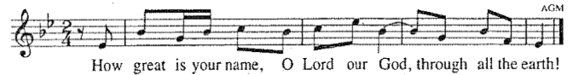
Your majesty is praised above the heavens,
On the lips of children and of babes,
You have found praise to foil your enemies,
To silence the foe and the rebel.

Antiphon: How great is your name, O Lord…

When I see the heavens, the work of your hands,
The moon and the stars which you arranged,
What are we, that you should keep us in mind,
Men and women, that you care for us?

Ant. How great is your name, O Lord…

Yet you have made us little less than gods,
And crowned us with honor and glory,
Gave us power over the works of your hands,
Put all things under our feet.

Ant. How great is your name, O Lord…

All of them, sheep and cattle,
Yes, even the savage beasts,
Birds of the air, and fish
That make their way through the waters.

Ant. How great is your name, O Lord…

Second Reading 2 Timothy 1:1-14
This message written from Paul to Timothy is a personal message of encouragement. In the face of hardship and persecution, Timothy is reminded that his faith is a gift of God. He is encouraged to exercise that faith with the help of the Holy Spirit.

A reading from Second Timothy.

Paul, an apostle of Christ Jesus by the will of God, for the sake of the promise of life that is in Christ Jesus, to Timothy, my beloved child: Grace, mercy, and peace from God the Father, and Christ Jesus our Lord.
I am grateful to God—whom I worship with a clear conscience, as my ancestors did—when I remember you constantly in my prayers night and day. Recalling your tears, I long to see you so that I may be filled with joy. I am reminded of your sincere faith, a faith that lived first in your grandmother Lois, and your mother Eunice, and now, I am sure, lives in you.
For this reason I remind you to rekindle the gift of God that is within you through the laying on of my hands; for God did not give us a spirit of cowardice, but rather a spirit of power and of love and of self-discipline.
Do not be ashamed, then, of the testimony about our Lord or of me his prisoner, but join with me in suffering for the gospel, relying on the power of God, who saved us and called us with a holy calling, not according to our works but according to God’s own purpose and grace. This grace was given to us in Christ Jesus before the ages began, but it has now been revealed through the appearing of our Savior Christ Jesus, who abolished death and brought life and immortality to light through the gospel. For this gospel I was appointed a herald and an apostle and a teacher, and for this reason I suffer as I do. But I am not ashamed, for I know the one in whom I have put my trust. I am sure that God is able to guard until that day everything that I have entrusted to God. Hold to the standard of sound teaching that you have heard from me, in the faith and love that are in Christ Jesus. Guard the good treasure entrusted to you, with the help of the Holy Spirit living in us.

Word of God, word of life.
Thanks be to God.

Gospel Acclamation
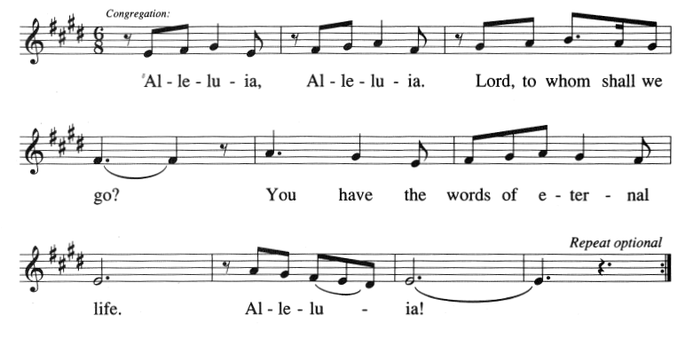

Holy Gospel Luke 17:5-10
Faith the size of a mustard seed
On the way to Jerusalem, Jesus instructs his followers about the power of faith and the duties of discipleship. He calls his disciples to adopt the attitude of servants whose actions are responses to their identity rather than works seeking reward.

A reading from the Holy Gospel according to St. Luke.
Glory to you, O Lord.
The apostles said to the Lord, “Increase our faith!” The Lord replied, “If you had faith the size of a mustard seed, you could say to this mulberry tree, ‘Be uprooted and planted in the sea,’ and it would obey you.
“Who among you would say to your slave who has just come in from plowing or tending sheep in the field, ‘Come here at once and take your place at the table’? Would you not rather say, ‘Prepare supper for me, put on your apron and serve me while I eat and drink; later you may eat and drink’? Do you thank your slave for doing what was commanded? So you also, when you have done all that you have been ordered to do, say, ‘We are worthless slaves; we have done only what we ought to have done!’”

The Gospel of the Lord.
Praise to you, O Christ.

Sermon Pastor Tina Reyes

Hymn of the Day Canticle of the Sun
“All Creatures of Our God and King”
Lasst uns erfreuen
words by William Henry Draper (1919),
after St. Francis of Assisi (ca. 1181-1226)
Setting by Stephen Mager

Today’s special emphasis on the gift of God’s creation is inspired by Saint Francis of Assisi, whose traditional feast day is October 4.

All: All creatures of our God and King,
Lift up your voice and let us sing;
Alleluia! Alleluia!
O burning sun with golden beam,
And silver moon with softer gleam,
Alleluia! Alleluia!
Alleluia, alleluia, alleluia!

All: O rushing winds and breezes soft,
O clouds that ride the winds aloft,
Alleluia! Alleluia!
O rising morn, in praise rejoice;
O lights of evening, find a voice:
Alleluia! Alleluia!
Alleluia, alleluia, alleluia!
High voices: O flowing waters, pure and clear,
Make music for your Lord to hear,
Alleluia! Alleluia!
O fire so masterful and bright,
Providing us with warmth and light,
Alleluia! Alleluia!
Alleluia, alleluia, alleluia!

Low voices: Dear mother earth, who day by day
Unfolds rich blessings on our way,
Alleluia! Alleluia!
The fruits and flow’rs that verdant grow,
Let them God’s glory also show!
Alleluia! Alleluia!
Alleluia, alleluia, alleluia!

All: O everyone of tender heart,
Forgiving others, take your part.
Alleluia! Alleluia!
All you who pain and sorrow bear,
Praise God, and on God cast your care!
Alleluia! Alleluia!
Alleluia, alleluia, alleluia!

Choir: And you, most kind and gentle death,
Waiting to hush our final breath,
Alleluia! Alleluia!
You lead to heav’n the child of God,
Where Christ our Lord the way has trod:
Alleluia! Alleluia!
Alleluia, alleluia, alleluia!

All: Let all things their Creator bless
And worship God in humbleness!
Alleluia! Alleluia!
O praise the Father, praise the Son,
And praise the Spirit, Three in One:
Alleluia! Alleluia!
Alleluia, alleluia, alleluia!
Amen.

Prayers of Intercession

As scattered grains of wheat are gathered together into one bread, so let us gather our prayers for the church, those in need, and all of God’s good creation.
A brief silence.
We pray for your holy church in every place and for those who serve following the example of Christ. Help them to live by faith and walk by the light of your gospel. God of grace,
hear our prayer.
For parts of the world ravaged by natural disaster: relieve those affected by floods, wildfires, droughts, earthquakes, tornadoes, and hurricanes. God of grace,
hear our prayer.
For every nation and for those entrusted with authority: grant our leaders self-discipline in all things, and inspire them with love for your people. God of grace,
hear our prayer.
For victims of violence, abuse, and neglect: heal those who have been harmed and protect those who are vulnerable. For all who are sick especially Jack, Jodi, Jan, Rudolph, Mark, Dorothy, Brittany, Jeri, Linda, Mary, David, Julie, Nick, Anna, Evonne, Ronald, Meredith, Katie, Joe, Michael, Marcie, and Anne-Marie. God of grace,
hear our prayer.
For this and every congregation: rekindle your gifts within your people, and inspire councils, committees, and individuals to plan and work together that all may know your love. God of grace,
hear our prayer.
Here other intercessions may be offered.
In thanksgiving that you have abolished death, and for the saints who have died (especially). Bring us all to eternal life with you. God of grace,
hear our prayer.
Gathered together in the sweet communion of the Holy Spirit, gracious God, we offer these and all our prayers to you; through Jesus Christ, our Savior.
Amen.

The Peace
The presiding minister greets the assembly with the peace of Christ, the people responding
“And also with you.”

The people may greet one another with a sign of Christ’s peace. After greeting one another, the assembly is seated.

Meal
God feeds us with the presence of Jesus Christ
The Offering

Offertory As the Grains of Wheat ELW # 465
[from Now the Feast ]

Offertory Prayer

Blessed are you, O God,
for the greening earth given for all, for the talents we are given to share, and for this bread and wine. Transform us to be the body of Christ, that, feasting on this food and drink, our lives may reflect your generosity; through Christ our Lord. Amen.

The Great Thanksgiving

You are welcome at God’s table. If you believe that here Christ is truly present in, with and under the elements of bread and wine, and you have partaken in a home congregation or perceive the welcome of Christ to this table, you are welcome to receive. Children of God who do not commune are invited to come forward for the blessing. Grape juice (the darker colored liquid) is provided in the tray of individual cups for those who prefer this alternative. Follow the instructions of the ushers as they direct you to the two stations on either side of the sanctuary to receive the bread and the wine, making your way back to your seat by the center aisle.

The Lord be with you.
And also with you.
Lift up your hearts.
We lift them to the Lord.
Let us give thanks to the Lord our God.
It is right to give our thanks and praise.

It is indeed right, our duty and our joy…we praise your name and join their unending hymn:

Holy, Holy, Holy (Sanctus)
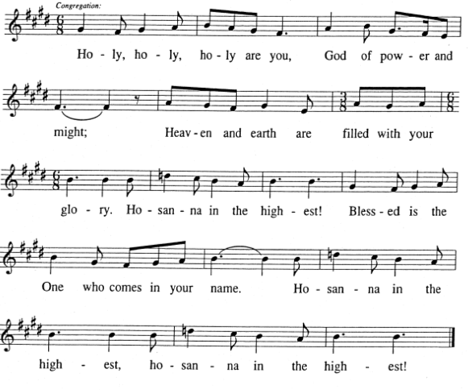

Thanksgiving at the Table

Holy, mighty, and merciful Lord, heaven and earth are full of your glory. In great love you sent to us Jesus, your Son, who reached out to heal the sick and suffering, who preached good news to the poor, and who, on the cross, opened his arms to all. In the night in which he was betrayed, our Lord Jesus took bread, and gave thanks; broke it, and gave it to his disciples, saying: Take and eat; this is my body, given for you. Do this for the remembrance of me.
Again, after supper, he took the cup, gave thanks, and gave it for all to drink, saying: This cup is the new covenant in my blood, shed for you and for all people for the forgiveness of sin. Do this for the remembrance of me.
Remembering, therefore, his death, resurrection, and ascension, we await his coming in glory.Pour out upon us the Spirit of your love, O Lord, and unite the wills of all who share this heavenly food, the body and blood of Jesus Christ, our Lord; to whom, with you and the Holy Spirit, be all honor and glory, now and forever.

The Lord’s Prayer

Eternal Spirit, Earth-maker, Pain-bearer, Life-giver,
Source of all that is and that shall be,
Father and Mother of us all,
Loving God, in whom is heaven:
The hallowing of your name echo through the universe!
The way of your justice be followed by the peoples of the world!
Your heavenly will be done by all created beings!
Your commonwealth of peace and freedom sustain our hope and come on earth.
With the bread we need for today, feed us.
In the hurts we absorb from one another, forgive us.
In times of temptation and test, strengthen us.
From trials too great to endure, spare us.
From the grip of all that is evil, free us.
For you reign in the glory of the power that is love, now and forever. Amen.
Invitation to Communion
The presiding minister invites the assembly to Christ’s table, where all are welcome. The assembly is seated.

Lamb of God (Agnus Dei)
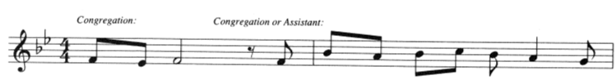
Lamb of God, you take a - way the sin of the

world: have mer - cy on us, mer - cy on us,

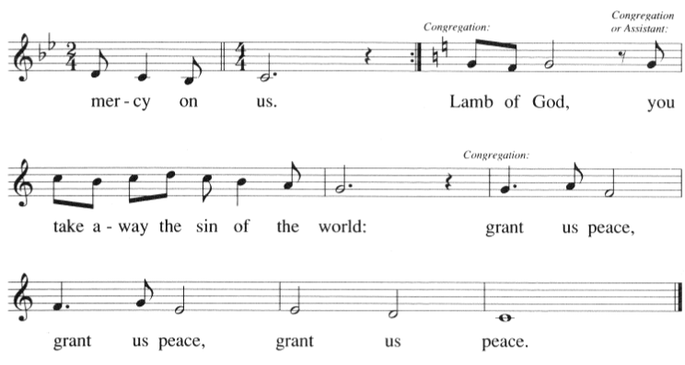
Communion Hymn Bread of Life from Heaven ELW # 474
Argentine Santo

Communion Anthem Steal Away
African-American spiritual
Setting by Brazeal Dennard (1929-2010)

Composer, singer, and educator Brazeal Dennard was born, raised, and educated in Detroit, Michigan. A music educator in Detroit public schools, he founded and directed the Brazeal Dennard Chorale in 1972. As a composer and conductor, he was especially dedicated to the preservation and promotion of the African-American spiritual as a serious musical form.

The assembly stands for the Table Blessing.

Table Blessing

The body and blood of our Lord Jesus Christ strengthen you and keep you in his grace. Amen.

Prayer after Communion

God of blessing,
at this table we have seen you face to face,
and in the gift of Christ’s body and blood,
our hearts have been refreshed.
Send us now to shine with your goodness
and bear witness to the one we have received:
Jesus Christ, our Savior and Lord.
Amen.

Sending
God blesses us and sends us in mission to the world

Blessing

All are invited to process outside for the Blessing of the Animals.
Please join in our processional hymn.

Processional Hymn Joyful, Joyful We Adore Thee # 836
Hymn to Joy

Liturgy of Blessing

God created us and placed us on the earth
to be stewards of all living things,
therefore let us proclaim the glory of our Creator, saying:
O God, how wonderful are the works of your hands.

Blessed are you, O Lord of the Universe; you create the animals
and give us the ability to train them to help us in our work.
O God, how wonderful are the works of your hands.

Blessed are you, O Lord of the Universe;
you give us food from animals to replenish our energies.
O God, how wonderful are the works of your hands.

Blessed are you, O Lord of the Universe; for the sake of our comfort
you give us domestic animals as companions.
O God, how wonderful are the works of your hands.

Blessed are you, O Lord of the Universe; you care for us
even as you care for the birds of the air.
O God, how wonderful are the works of your hands.

Blessed are you, O Lord of the Universe; you offered your Son to us as the Passover lamb
and in him willed that we should be called your children.
O God, how wonderful are the works of your hands.

Prayer of Blessing over the Animals

Bless, O Lord, this (these) creature(s),
and fill our hearts with thanksgiving for its (their) being.

Dismissal

Sending Hymn Let All Things Now Living # 881
The ash grove

In Our Prayer Continually:
We give thanks for the life and faith of Jodi Williamson (stepmother of Jennifer Williamson). May God bring comfort and peace to her husband Jack Williamson and all her family and friends.
We pray for healing and comfort for Jan Harrington, as he recovers from recent back surgery. Dr. Harrington is a friend and teacher of Dr. Mager.
We pray for Jack Williamson (father of Jennifer Williamson) who has dementia. May him and his family find support in learning to find joy in the new.
We give thanks for the life and faith of Dorothy Bauer. May God bring comfort and peace to her daughter Jayne Moentmann and all her family and friends.
We pray for God’s comfort and peace for Rudolph Mueller who is now under hospice care.
We pray for Mark Doerries (close friend and colleague of Dr. Mager), as he continues to contend with a cancer diagnosis.
We pray for Brittany (niece of Ann and Bob Mottl) for her continued healing as she begins radiation treatments that will be followed by five months of chemotherapy.
We give thanks for Jeri Montalto (sister of Jody Kluender) as she has continued improvement and feels very well.
We pray for God’s comfort and strength to be with Mary Baker Findley (sister of Vicki Baker Lottes) with stage 4 cancer and her husband David Findley whose Alzheimer’s is progressing rapidly.
We pray for Julie Murthy (cousin of Emily Pelcak) as she starts her battle with cancer.
We pray for strength and wisdom for Nick Peppes (colleague of Gail Heyne Hafer) who is facing personal challenges.
We pray for God’s continued healing and strength for Anna (Roy Ledbetter’s daughter) as she resumes medical treatment for an on-going health issue.
We pray for God’s strength to be with Evonne Simmons as she lives with chronic illness.
We give thanks for Ronald Thompson’s (stepbrother of Kristin Soifer) recovery from the injury he sustained in a fall, and pray for him as he continues to face chronic illness.
We pray for healing and hope to be with Meredith Sallee (sister of Katy Koontz) during her treatment for cancer.
We pray for Joe Whelan (stepson to Tim Gutknecht) who is dealing with a genetic condition.
We pray for Michael Moentmann who lives with chronic illness.
We continue our prayers for Marcie Dowell as she lives with a heart condition. May God’s peace comfort her during this time.
We pray for Anne-Marie Bogdan (sister of Nathan Schroeder) as she lives with long-standing health conditions. May God’s comfort and strength be with her and her family.

Cover artwork: Our beautiful artwork is the handiwork of Bethel members. The front cover image is by Ella Welch. The interior image is by Kasia White.

Acknowledgments: Service liturgy and music reprinted from Evangelical Lutheran Worship (ELW), Copyright © 2006 Augsburg Fortress, and from Sundays and Seasons, Copyright © 2022 Augsburg Fortress. All rights reserved. Reprinted by permission under Augsburg Fortress Liturgies Annual License #37725.
Psalm 8: How Great is Your Name, music by Dom Gregory Murray, Copyright © 1963, The Grail, England. GIA Publications, Inc., Chicago, agent. Used by permission. OneLicense.net # A-704944. All rights reserved.

Bethel Announcements

Worship Games/Training
scheduled for October 1 has been postponed due to scheduling conflicts. Confirmation students have already received acolyte training and will be scheduled soon. Others who would like to acolyte (adults included) are asked to contact Jody Kluender to be added to the rotation. We hope to schedule training for other worship roles in the future. If you or your household would like to usher, please contact Carrie Costantin; if you’d like to help with Altar Guild, Kristin Soifer. Potential lectors (readers) or Communion assistants may contact KJ
Monahan.

Breadbreakers Anew for Fall 2022
(This message is NOT for folks who have already signed up for Breadbreakers this fall!)
It has been suggested that some Bethel members might be interested in a “Breadbreakers-style” group gathering that would happen during daytime hours. Think gathering for lunch, rather than dinner! If you are interested in joining such a group, please let Sue Flesch know, either via phone (314-862-4490) or email (susancflesch@gmail.com).

Adult Forum Kickoff Date Sunday, October 9th
Adult Forum is resuming at its normally scheduled time of 8:45 am on Sunday mornings. Our first session is scheduled for October 9th. Please mark your calendars and stay tuned for more information about that morning’s session.

Ushers Needed
We are setting up the fall schedule for ushers and are looking for volunteers to usher one Sunday a month. If you are willing to do so, please contact Carrie Costantin at cac6811@gmail.com or 314-413-8155.

Have Something for the Bethel Connection, Bulletin, Website, Narthex Information Board, or Facebook?
Email it to submissions@bethelstl.org by 9 a.m. Monday morning.

Today’s Worship Leaders

Celebrant & Preacher The Rev. Tina Reyes
Assisting Minister KJ Monahan
Steward Jody Kluender
First Lector and Communion Assistant Marie Walker
Second Lector and Communion Assistant Sue Flesch
Musicians Bethel Chancel Choir
Malinda Walter, flute
Dr. Stephen Mager, Music Director

7001 Forsyth Boulevard, St. Louis, MO 63105
Office Hours Mon-Fri 10 a.m.-2 p.m. (314) 863-3112

The Rev. Merle Brockhoff, Interim Pastor
Stephen Mager, dm, Organist and Music Director
The Rev. Tina Reyes (she/her/ella), Campus Pastor, LuMin St. Louis
Deb Grupe, Director of Child, Youth, and Family Ministry
Eric Townsley, Custodian, custodian@bethelstl.org
Anna Burkemper, Church Administrator, office@bethelstl.org

A Reconciling in Christ Congregation (a welcoming ministry to persons of all sexual orientations, gender identities, and gender expressions)
and A Green Congregation (for being stewards of the earth)
In Covenant with Lutheran Campus Ministry (LuMin), lcmstl.org

Have a prayer request? Email it to prayers@bethelstl.org anytime.
Note that the information you send to this address will get shared with a number of people who will be praying for you as well as the Sunday Holy Communion bulletin.

In support of our goal of being a caring, inclusive, Christ-centered community, we
  - care for God’s creation
  - promote the non-violence of Christ and care for those who suffer
  - participate in the Spirit toward a global religious community

